Title: LABORATORY 1 – PHYSIOLOGICAL INSTRUMENTATION

Purpose:

The purpose of this lab is to observe the operation of these instruments. Make a concerted effort to recognize and identify each on sight. Lastly to understand the application of the “black box” instrumentation to experiments and measurements of human physiological events.

Procedure:

1. Measure the length, width, and height of a textbook
2. Pour water in a beaker and state the volume. Then pour water from the beaker to a graduated cylinder.
3. State the mass of weight in g and mg
4. Add water to the beaker and state mass in g and mg
5. Grab Ph strip and measure the ph for A,B, and C with new Ph strips each time.
6. Take pulse for 15 and then for 60 minutes.

Results:

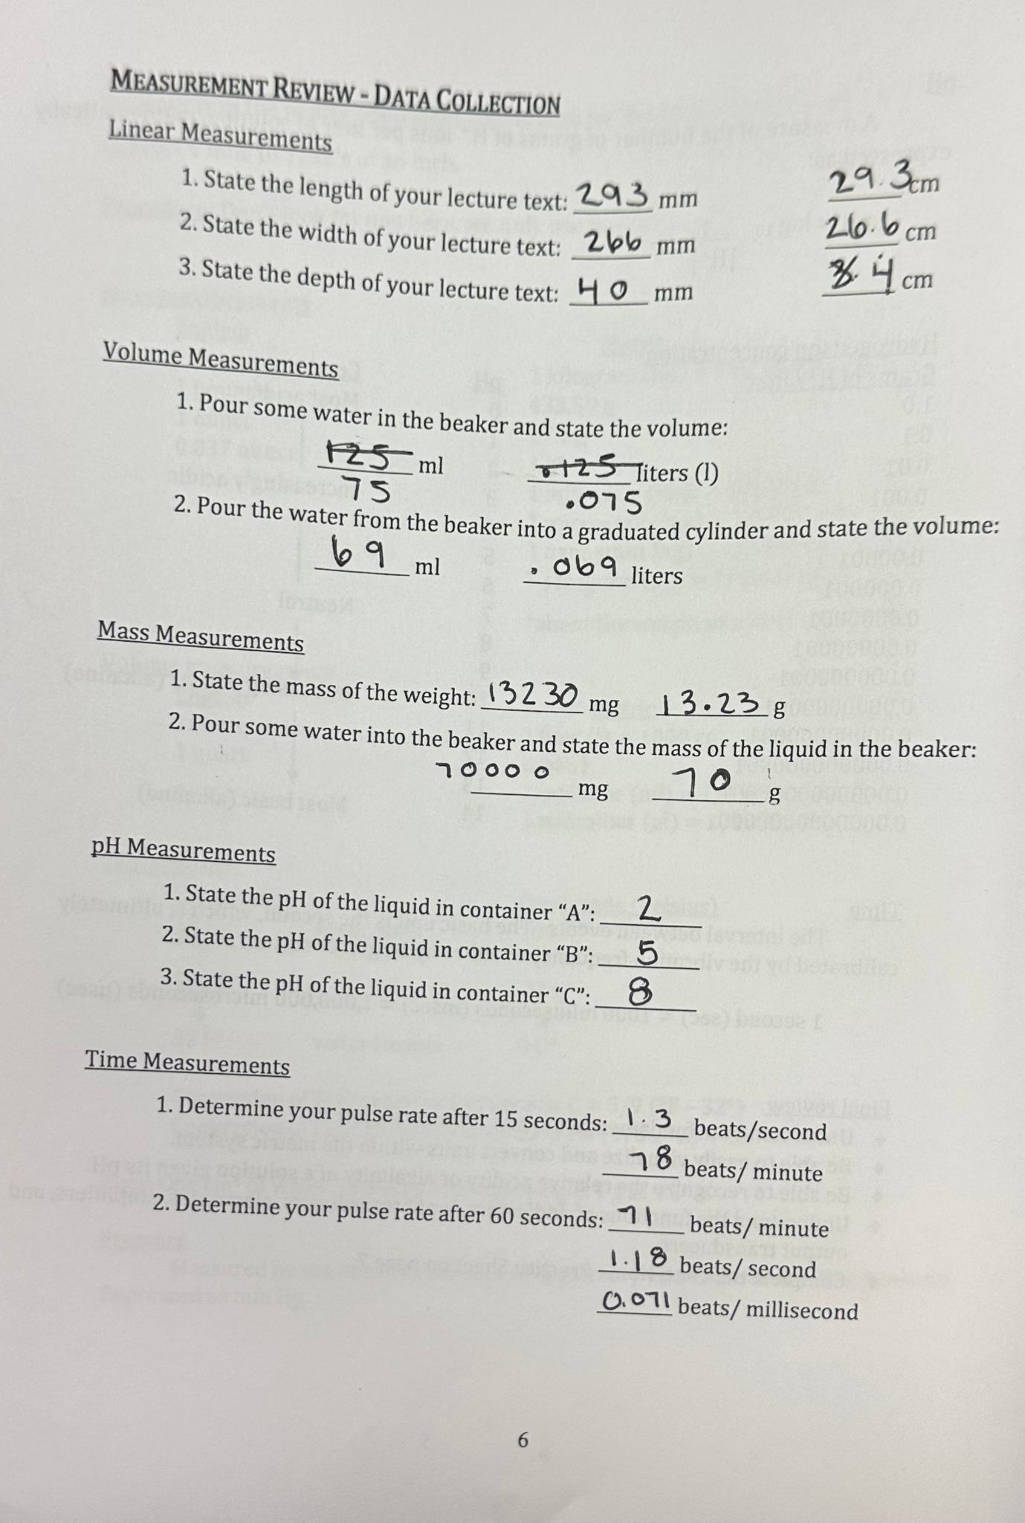

Discussion:

With the data, we can determine that the graduated cylinder was more precise compared to the beaker. But the beaker was able to hold a larger volume so if we needed a more precise measurement we would use the graduated cylinder but if we needed to measure a bigger volume we could use a beaker. Also, the data shows how we can convert L to ml, mm to cm, and beats per minute to beats per second which goes to shows how important conversions are in the metric system. Not shown in the data is the “black box” which was shown in class but we observed it taking the student's heartbeats with a device inserted in it and the computer was showing the data.

Conclusion:

In conclusion, our experiment comparing the use of a graduated cylinder and a beaker for volume measurements revealed important insights into precision and capacity. Additionally, our data analysis emphasized the significance of conversions within the metric system. It is worth noting that our experiment did not cover the "black box" concept, which was introduced during lab.